1. Open git basch and enter username



1. Enter user email address

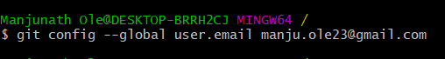

1. Navigate to folder change from c to d

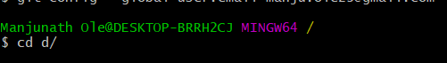

1. Create a Reporitor in Web page and copy the page.

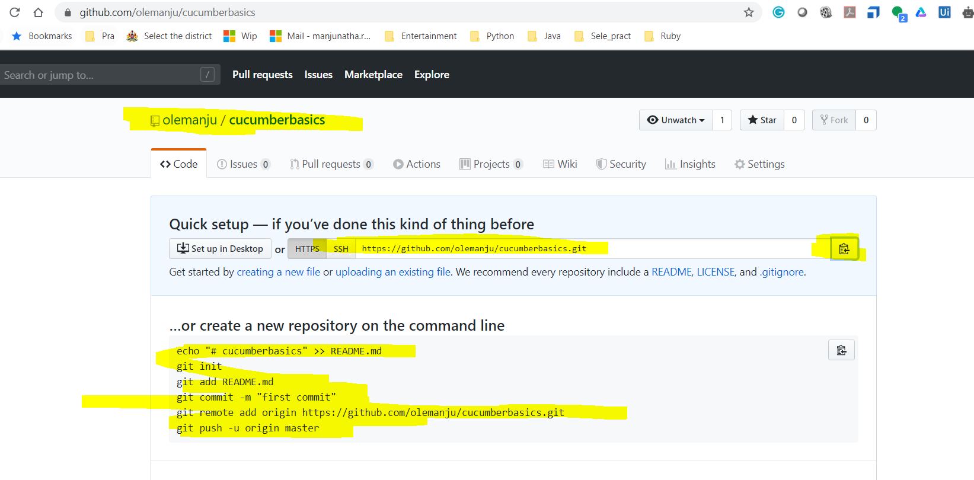

Then navigate to that folder and clone that git

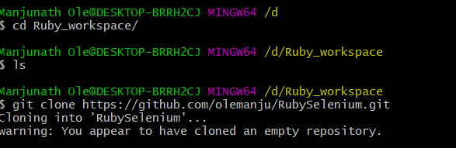

Move to that Foler from Basch

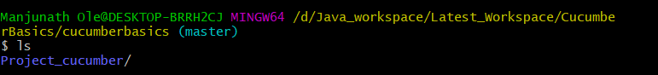

Add files to that folder

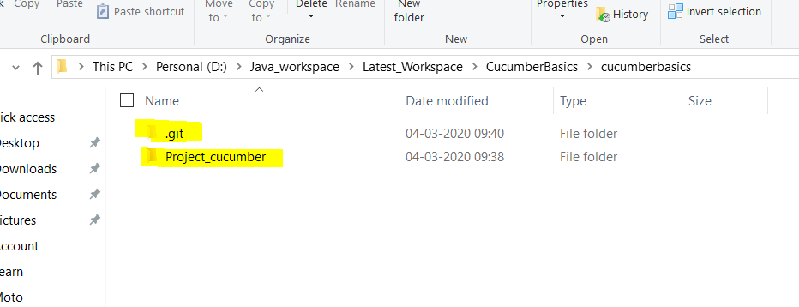

Then hit git sttaus- which are in red is not added

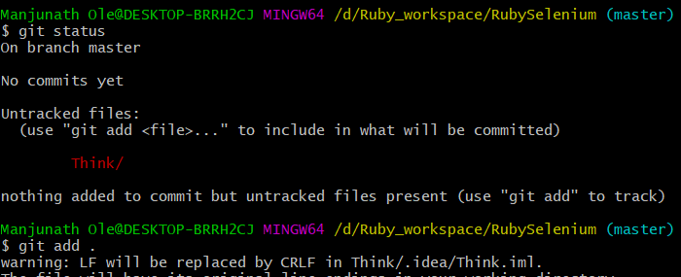

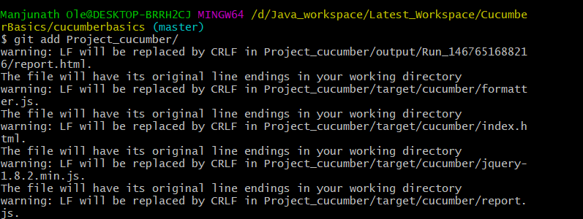

Then check the status

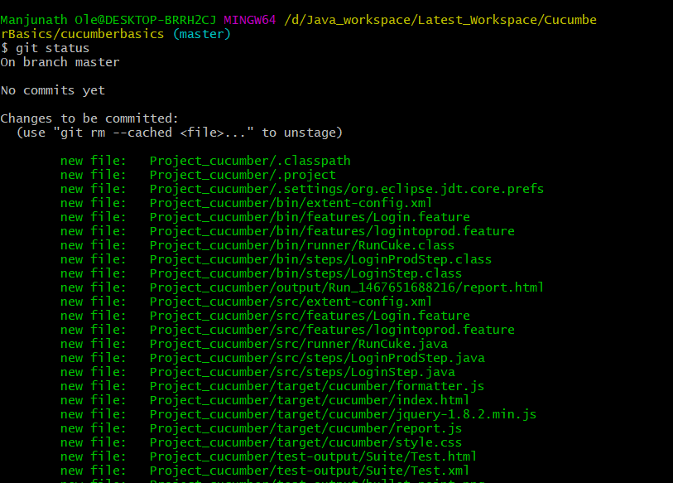

Then Commit the Changes.

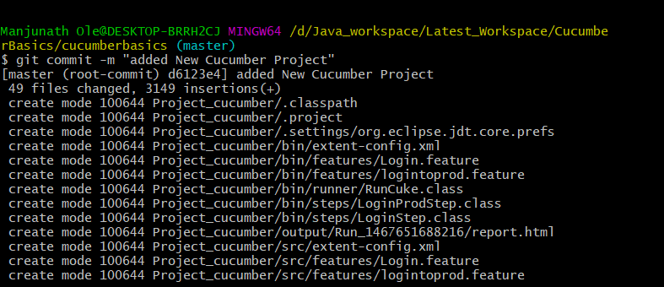

Execute the Push Statement

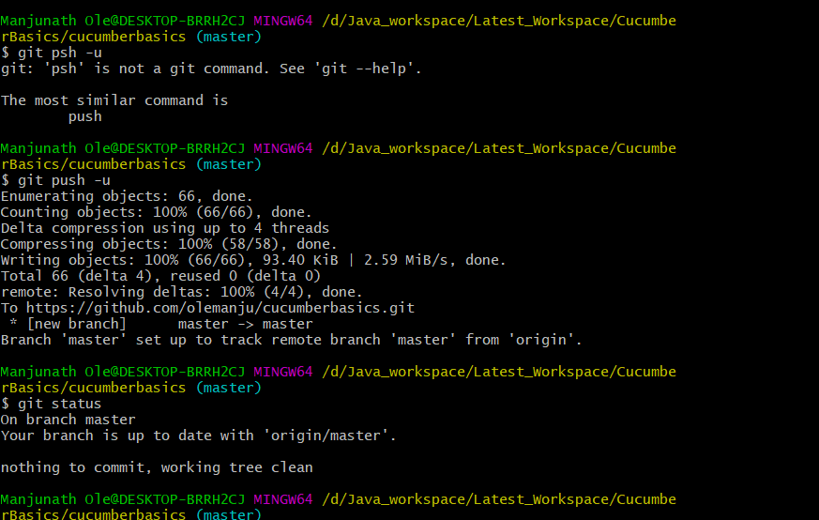

To add Single file every day.

Work on the files- in the editor

Once the task is completed.

Open gitbash-> Enter user name and password

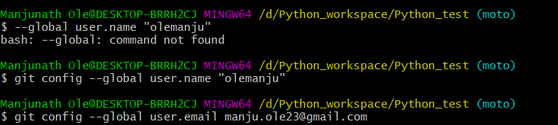

Then check Git status

git status

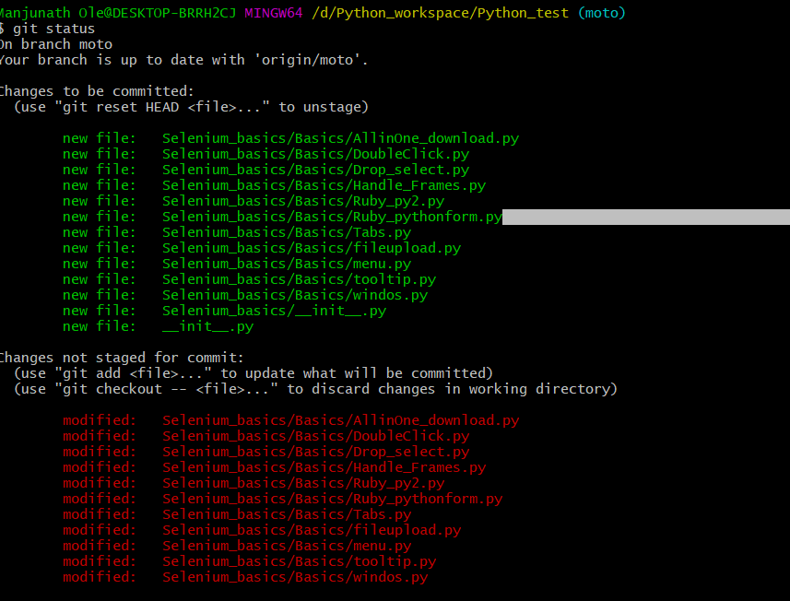

Which are in red not added to the repository.

To add those.. just enter

git add .(add space .)



Now check the status:

Git status

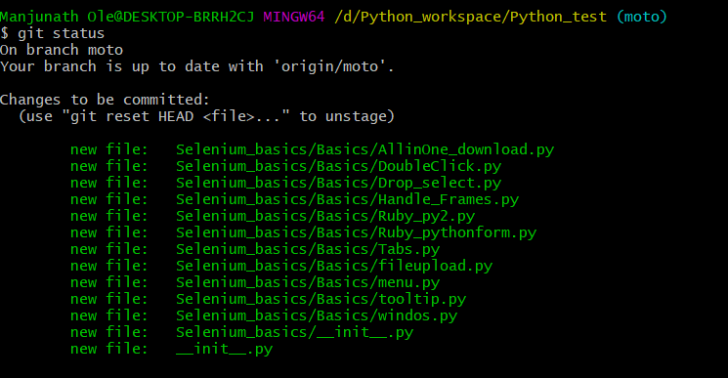

Now Commit the changes and add valid comment

Git commit –m “Added New file on 4th april”

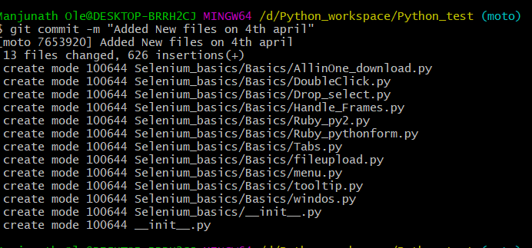

Finally push the changes:

Git push -u

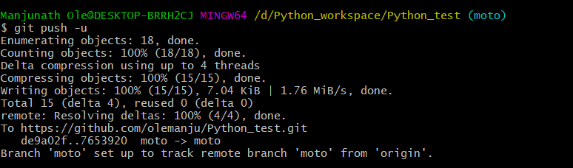

Check in the Git GUI

